╔══════════════════════════════════════════╗
║ CYBERSTER BLUE TEAM ║
║ INTERNSHIP PROGRAMME ║
╚══════════════════════════════════════════╝

WEEK 3 TASK REPORT
Suricata IDS Integration with Wazuh

OPERATIVE | Unyimeabasi Sunday Jones
PROGRAMME | Cyberster Blue Team Internship
PHASE | Phase One — SOC Operations & SIEM Foundations
WEEK / DAYS | Week 3 // Days 15 – 21
TRACK | Blue Team
CLASSIFICATION | INTERNAL USE ONLY

[ MISSION OBJECTIVES ]

- 01. Install and configure Suricata IDS on Kali Linux VM
- 02. Write three custom Suricata detection rules
- 03. Integrate Suricata eve.json with Wazuh SIEM
- 04. Perform network + host alert correlation
- 05. Implement GeoIP-based firewall blocking with ipset/iptables

// EXECUTIVE SUMMARY
Week 3 extended the defensive stack built in Weeks 1 and 2 by adding a network-level detection layer. Wazuh monitors what hosts report about themselves, file changes, authentication events, process activity. Suricata monitors the wire, every packet flowing across the network interface in real time. Together they leave significantly fewer blind spots than either tool alone.

By the end of Day 21 the lab environment had Suricata running in IDS mode on the Kali Linux VM, three custom detection rules operational, Suricata alerts flowing into the Wazuh dashboard via the eve.json integration, and GeoIP-based IP blocking configured using ipset and iptables for China and Russia IP ranges. The week produced real detections: Nmap SYN scans were caught by the custom scan detection rule, ICMP floods triggered the flood detection threshold rule, and network alerts were correlated with host-based FIM alerts in the Wazuh Threat Hunting module.

NOTE: The HTTP Directory Traversal rule was written correctly but could not be triggered via the Python HTTP server because Python's SimpleHTTPServer normalizes path traversal sequences before they reach the wire. The rule syntax is valid and would fire against a real web server that passes the raw URI to the network. This is documented as an environment limitation, not a rule defect.

// DAYS 15 – 16 // SURICATA INSTALLATION & CONFIGURATION
› What is Suricata and Why It Belongs Here
Wazuh is host-based. It collects data that the operating system generates about itself. Suricata is network-based — it sits directly on a network interface and inspects every packet in real time, comparing traffic against a ruleset and generating alerts when something matches. An attacker entering through a network exploit appears in Suricata before touching anything Wazuh would log. An attacker who already has access and is modifying files will appear in Wazuh but may generate no network signatures at all. Running both closes most of the gap between those two scenarios.

Suricata was run in IDS mode this week. IDS observes and logs without interfering with traffic. IPS mode sits inline and can actively drop matching packets, but requires a more complex network topology to implement correctly in a lab. IDS first, understand what you are seeing, then consider prevention.
› Installation
Suricata was already present on the Kali VM. Version confirmed as 8.0.3-1.
$ suricata --version
[ 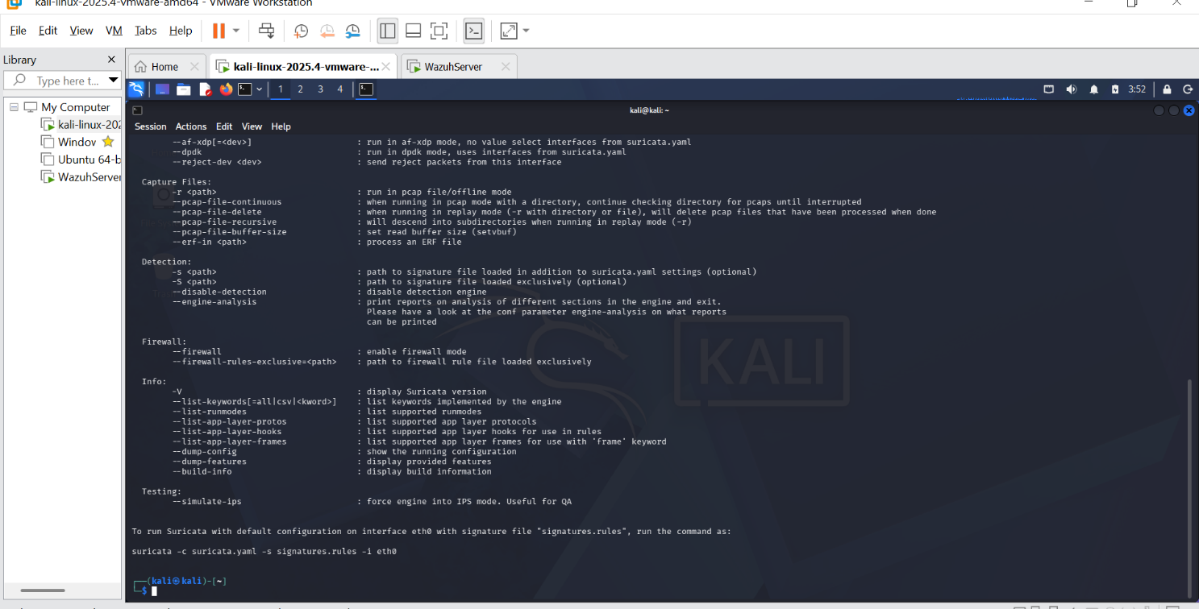› Network Interface Identification
Running ip a on Kali identified two relevant interfaces. eth1 carries the 172.16.0.0/24 lab network (Host-Only, VMnet1) where the Wazuh server sits at 172.16.0.134. eth0 carries the 10.10.10.0/24 NAT network. Since inter-VM lab traffic primarily flows over eth1, Suricata was configured to monitor eth1.
$ ip a
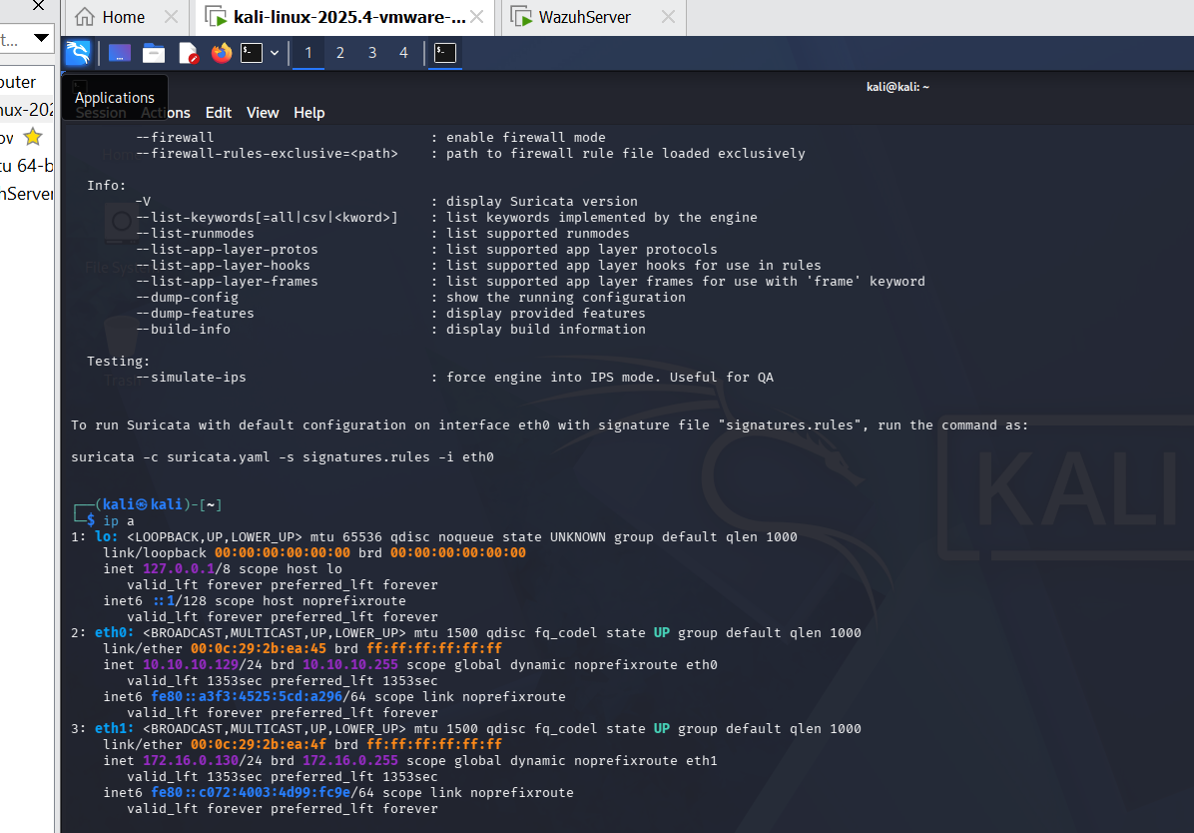› suricata.yaml Configuration
Three changes were made to /etc/suricata/suricata.yaml. HOME_NET was set to cover both lab subnets. The af-packet interface was set to eth1. Community-id was enabled for cross-tool correlation. The af-packet setting is the most critical — if the wrong interface is specified Suricata starts without errors but sees no traffic. The only way to catch this mistake is to check whether fast.log remains empty after generating traffic.
$ sudo nano /etc/suricata/suricata.yaml
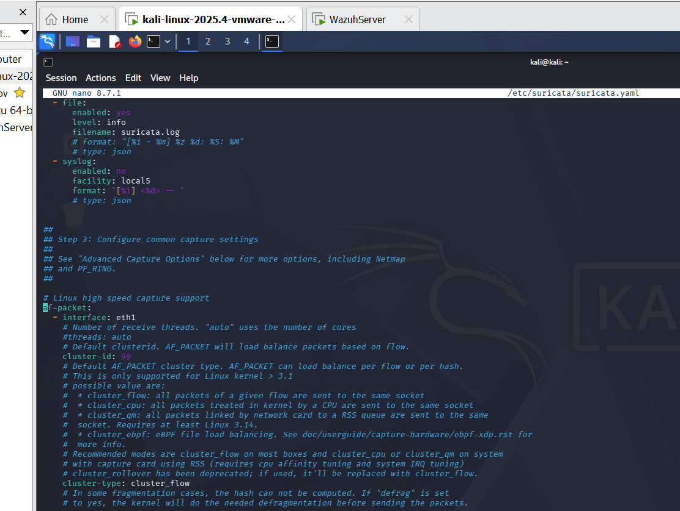› Service Status
$ sudo systemctl start suricata
$ sudo systemctl enable suricata
$ sudo systemctl status suricata
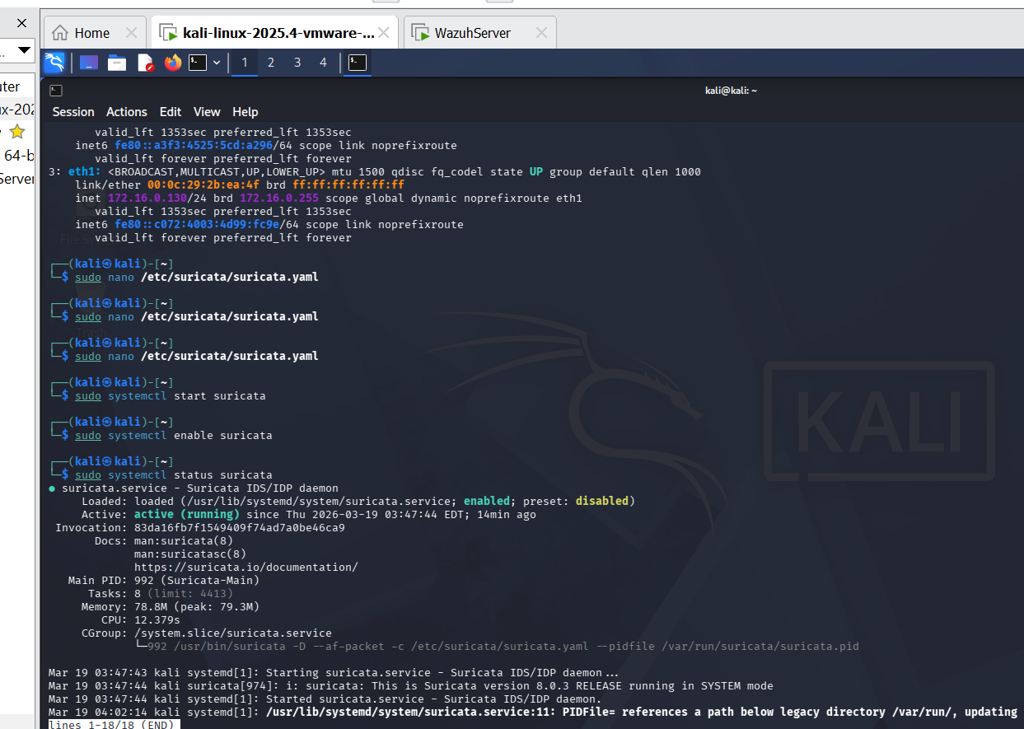› Traffic Verification — fast.log and eve.json
After starting Suricata, test traffic was generated from Kali: ping to the Wazuh server, curl requests, and an nmap scan. Default ruleset alerts appeared in fast.log within seconds, confirming the interface was correctly configured and traffic was being captured.
fast.log is the compact human-readable alert log — one line per alert showing timestamp, rule message, and IP:port pairs. eve.json is the full structured JSON log containing every event Suricata generates: flows, DNS queries, HTTP metadata, TLS certificate information, and full alert detail. eve.json is what Wazuh reads during integration.
$ sudo tail -f /var/log/suricata/fast.log
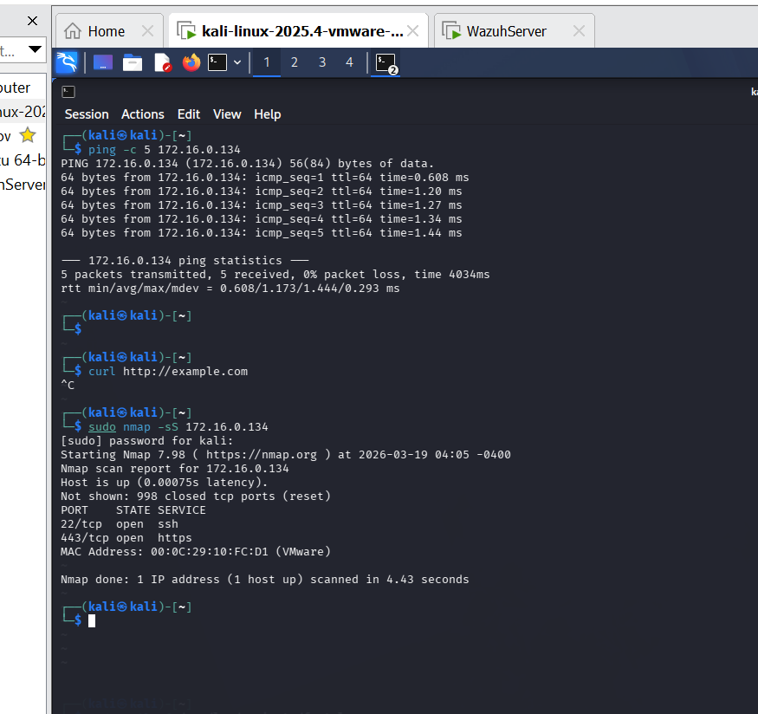$ sudo tail -5 /var/log/suricata/eve.json
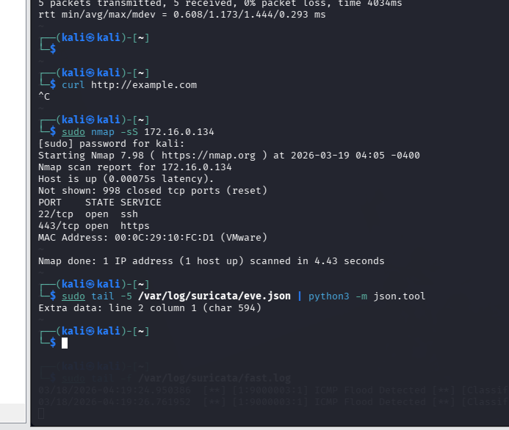
// DAY 17 // CUSTOM SURICATA RULE WRITING
› Ruleset Update
suricata-update was run to pull the latest Emerging Threats community ruleset. This is a community-maintained collection covering thousands of known threats. Updating is a scheduled task in production — running it once here confirms the update workflow and ensures default coverage is current.
$ sudo suricata-update
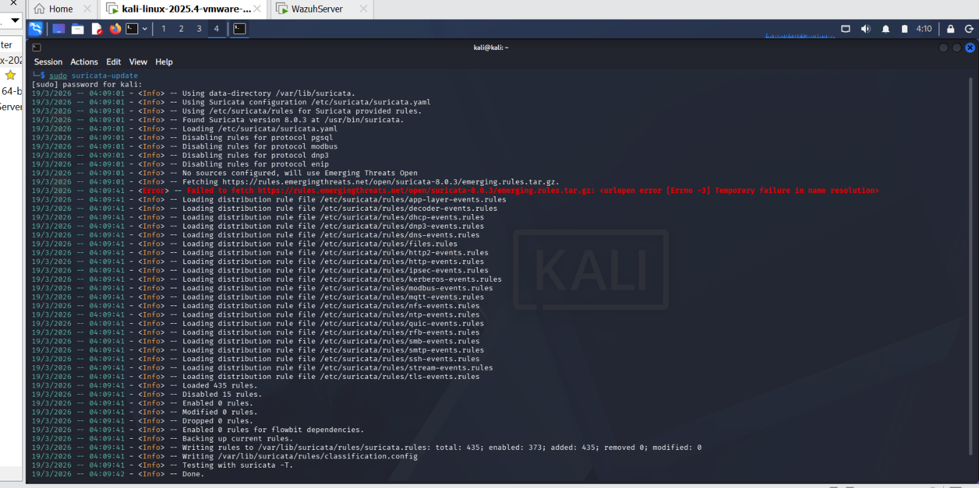
› Rule Structure
A Suricata rule has two parts. The header defines the action, protocol, source address/port, direction arrow, and destination address/port. The options section in parentheses defines conditions that must be true for the rule to fire. The sid must be unique — custom rules use SIDs above 9000000 to avoid conflicts with the community ruleset. 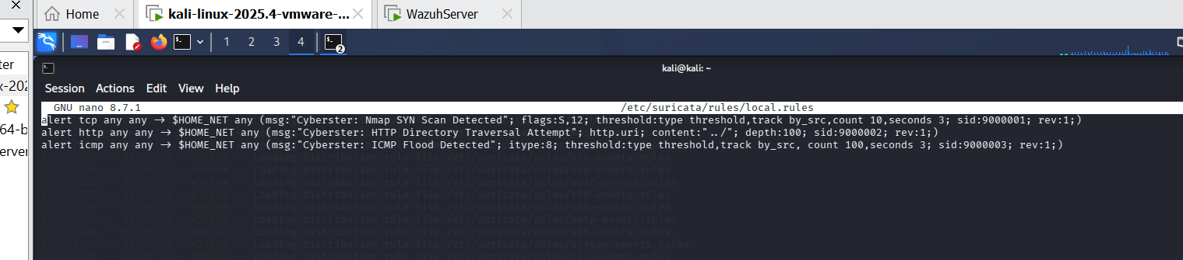
$ /etc/suricata/rules/local.rules → /var/lib/suricata/rules/local.rules
› Rule 1 — Nmap SYN Scan Detection (SID: 9000001)
Threat Scenario
Nmap SYN scans send TCP packets with only the SYN flag set in rapid succession across multiple ports. This is the most common reconnaissance technique. A single SYN packet to an open port is normal — a burst of SYN packets across many ports from one source in a short window is a scan.
Rule
$ alert tcp any any -> $HOME_NET any (msg:"NMAP TCP SYN Scan"; flags:S; threshold:type both, track by_src, count 20, seconds 10; sid:9000001; rev:1;)
How it works
flags:S matches TCP packets with only the SYN flag set. The threshold fires the alert only when 20 such packets arrive from the same source within 10 seconds — avoiding alerts on normal TCP connection setups while catching rapid scanning behaviour.
Test
$ sudo nmap -sS 172.16.0.134
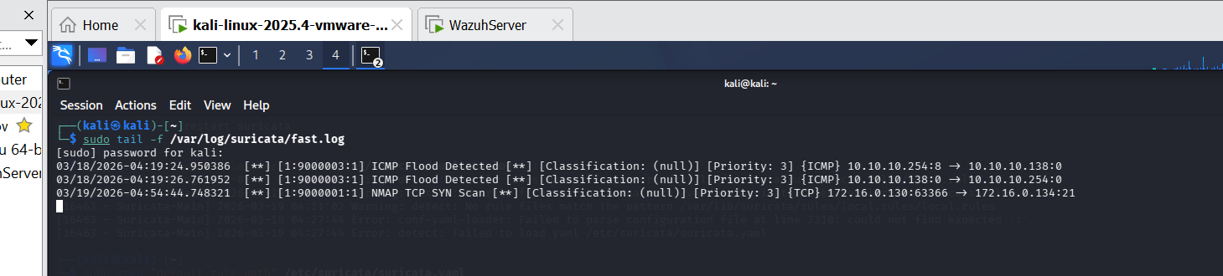

[ OK ] Rule 9000001 confirmed firing
› Rule 2 — HTTP Directory Traversal (SID: 9000002)
Threat Scenario
Directory traversal attacks use sequences like ../ in HTTP request URIs to attempt to navigate outside the web root and access sensitive files such as /etc/passwd. This is a common web application attack technique mapped to OWASP A01 and multiple CVEs.
Rule
$ alert http any any -> $HOME_NET any (msg:"Possible Directory Traversal Attempt"; content:"../"; http_uri; sid:9000002; rev:1;)
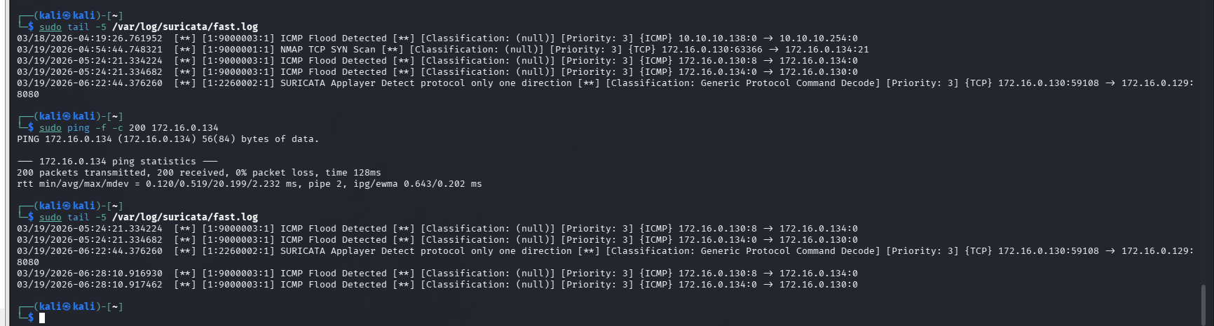

How it works
alert http uses Suricata's HTTP application layer parser to inspect decoded HTTP traffic. content:"../" matches the traversal sequence. http_uri restricts matching to the URI field specifically rather than the full packet payload, reducing false positives from legitimate content that might contain the string.
Environment Limitation
Python's SimpleHTTPServer normalizes path traversal sequences before they reach the network layer, meaning the raw ../ string never appears on the wire. The rule is syntactically correct and was validated by Suricata's rule loader with no errors. It would fire against a real web server passing the raw URI to the network.
[ WARN ] Rule 9000002 loaded — environment limitation prevented live trigger
› Rule 3 — ICMP Flood Detection (SID: 9000003)
Threat Scenario
An ICMP flood sends hundreds of ping requests per second from one source to one destination, overwhelming the target's ability to process them. This is a volumetric denial of service technique. A single ICMP echo request is normal network diagnostics — hundreds per second from the same source is an attack.
Rule
$ alert icmp any any -> $HOME_NET any (msg:"ICMP Flood Detected"; threshold:type limit, track by_src, count 10, seconds 5; sid:9000003; rev:1;)
How it works
itype:8 matches ICMP echo request packets specifically. The threshold:type limit setting fires once per source IP per 5-second window regardless of how many packets arrive — preventing the log from being flooded with thousands of identical entries during an active attack. Without the threshold, a 10-second flood would generate thousands of identical alerts.
Test
$ sudo ping -f -c 200 172.16.0.134
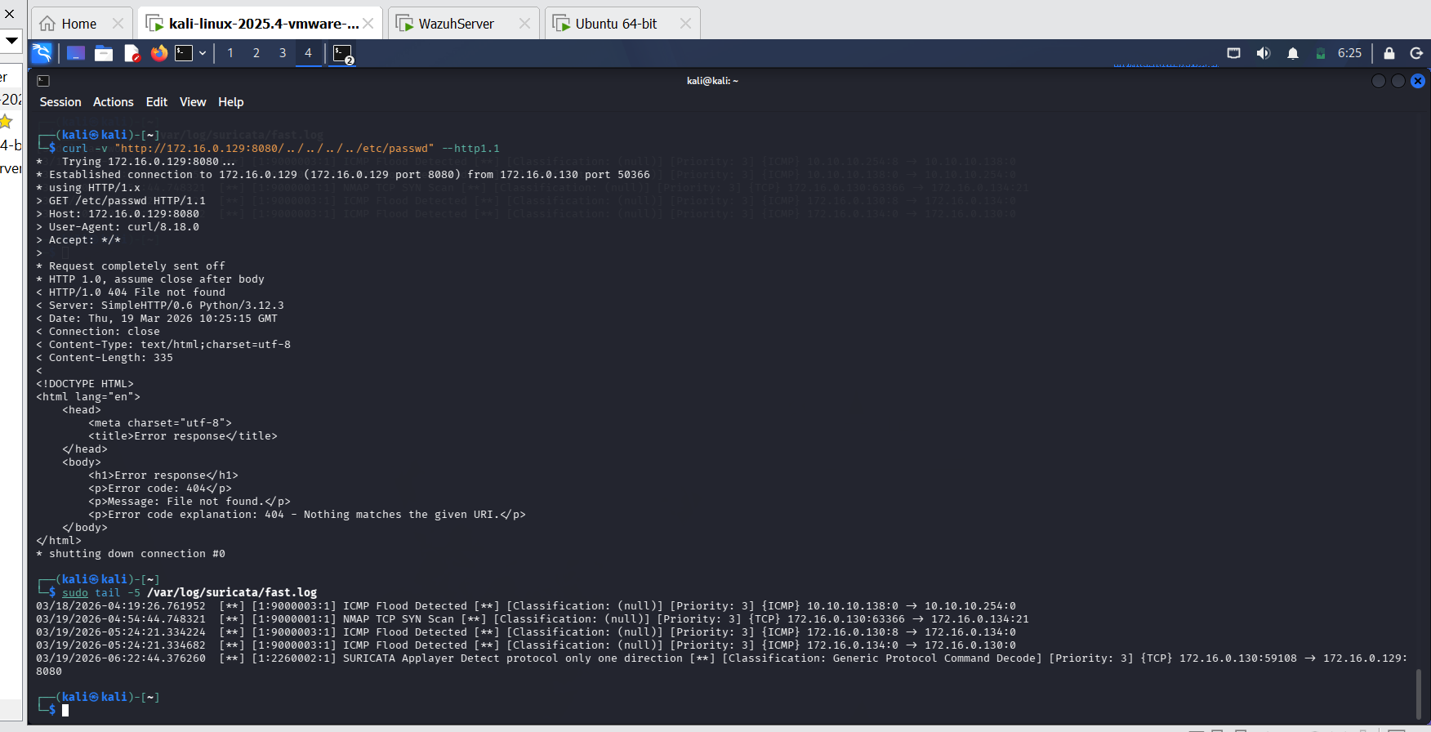
[ OK ] Rule 9000003 confirmed firing

// DAYS 18 – 19 // SURICATA + WAZUH INTEGRATION
› How the Integration Works
The integration connects Suricata's output to Wazuh's ingestion pipeline through the agent running on Kali. The agent is told to monitor eve.json the same way it monitors any other log file. When Suricata writes a new alert to eve.json, the agent reads it, forwards it to the Wazuh Manager, the Manager runs it through the Suricata decoder which extracts structured fields, the parsed event is checked against Wazuh's Suricata-specific rules, and the resulting alert appears in the dashboard alongside all host-based events.
The full path: Network packet → Suricata rule match → eve.json write → Wazuh agent reads file → Manager receives event → Suricata decoder parses JSON → Rule match → Dashboard alert.
› Agent Configuration
A localfile block was added to /var/ossec/etc/ossec.conf on the Kali agent pointing to /var/log/suricata/eve.json with log_format set to json. Setting the wrong log format — syslog instead of json — causes the agent to read the file but fail to parse the JSON structure, resulting in events arriving at the Manager as unprocessed raw text.
$ sudo nano /var/ossec/etc/ossec.conf
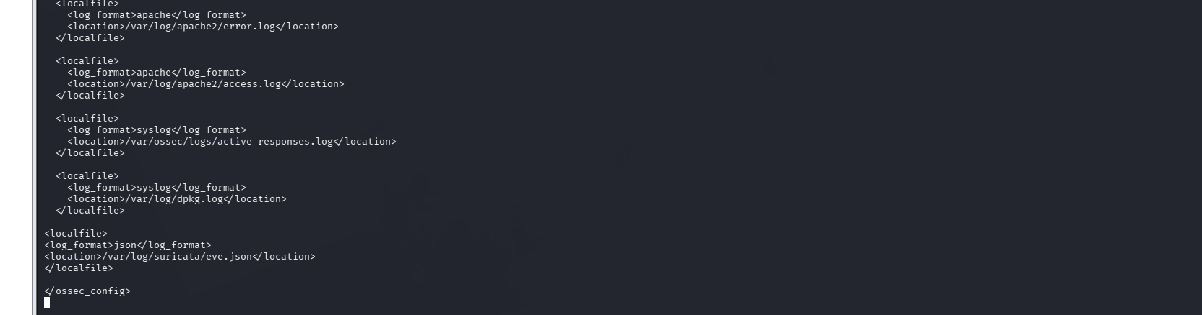$ sudo systemctl restart wazuh-agent
› Suricata Decoder Verification
The Wazuh Manager includes built-in decoders and rules for processing Suricata eve.json events. These were confirmed present in the /var/ossec/ruleset directory on the Wazuh Server before proceeding to test.
› Integration Test — Alerts in Dashboard
Test traffic was generated after the agent restart. An nmap scan and ICMP flood from Kali produced Suricata alerts in fast.log. These same events subsequently appeared in the Wazuh Security Events view labelled with the Suricata rule group, confirming the full pipeline was working.
$ sudo nmap -sS 172.16.0.134
$ sudo ping -f -c 200 172.16.0.134
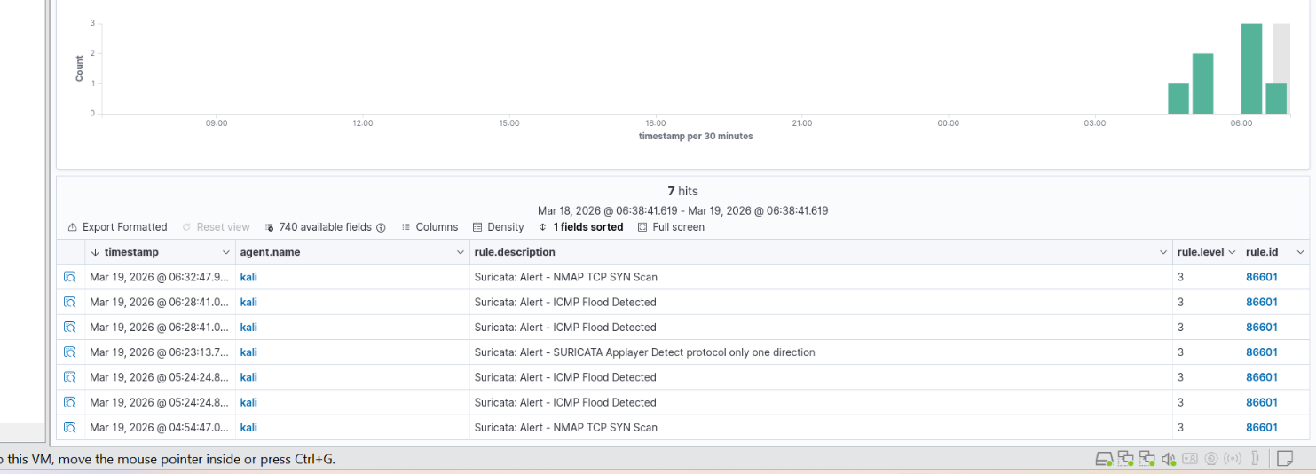› Correlation Exercise
The most significant exercise of the week. An nmap scan was run from Kali against the Wazuh Server, generating a Suricata network alert. Then a test file was created in /etc on Kali, generating a Wazuh FIM alert. Both events were pulled into a single Threat Hunting view filtered by the time window covering both actions.
$ sudo nmap -sS 172.16.0.134
$ sudo touch /etc/suricata_correlation_test.txt
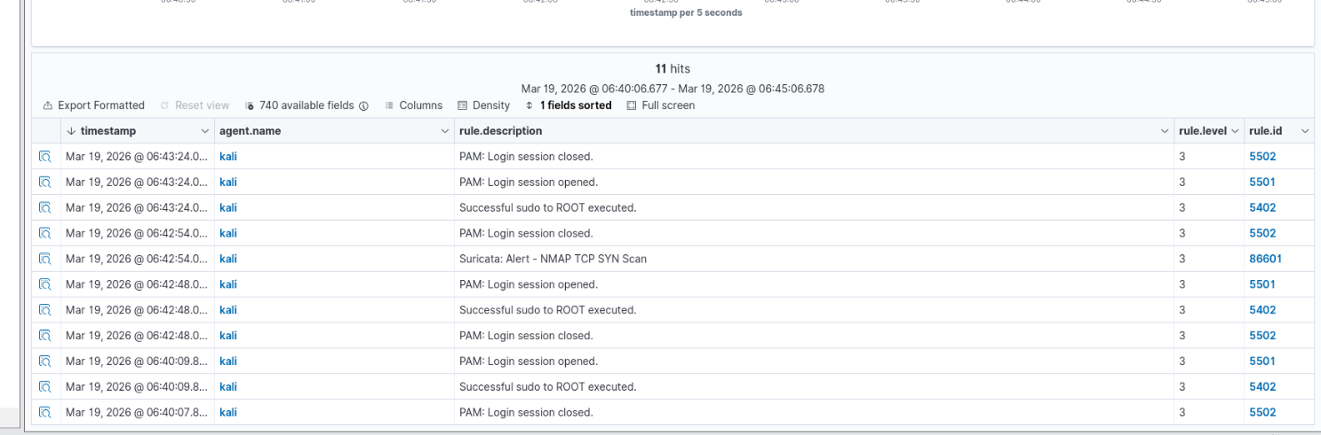What the Suricata alert shows alone: a SYN scan from 172.16.0.130 to 172.16.0.134 — reconnaissance activity. What the FIM alert shows alone: a file was created in /etc — possibly routine, possibly suspicious. What the combined view shows: the same source machine that conducted reconnaissance then made a filesystem change within minutes. That sequence is a meaningful signal. Reconnaissance followed by file system activity on the attacker machine suggests the scan found something and action followed. Neither alert alone tells that story.

// DAYS 20 – 21 // GEOIP BLOCKING & FIREWALL RULES
› Concept and Limitations
GeoIP blocking loads IP address ranges assigned to specific countries into the firewall and drops all traffic from those ranges. The underlying idea is that if an organisation has no legitimate users or partners in a particular country, blocking that country's IP ranges reduces attack surface with very low risk of affecting legitimate users. This is a real technique used in production environments.
Its limitations must be understood. IP geolocation is not perfectly accurate. VPNs, Tor exit nodes, and cloud infrastructure allow attackers to appear to originate from any country. A sophisticated attacker simply routes through an allowed country. GeoIP blocking is most effective against low-sophistication automated scanners, which make up a large proportion of real-world internet noise, not against targeted attacks.
› Package Installation
$ sudo apt-get install ipset -y
ipset is a kernel-level data structure for efficiently matching large numbers of IP addresses without checking each one against thousands of individual iptables rules. Loading 50,000 Chinese IP ranges as individual iptables rules would degrade network performance significantly. Loading them as a single ipset and referencing the set in one iptables rule is O(1) lookup time.
› Downloading Country Blocklists
IP address ranges for China (CN) and Russia (RU) were downloaded from ipdeny.com, which provides regularly updated CIDR format lists per country.
$ wget https://www.ipdeny.com/ipblocks/data/countries/cn.zone -O /tmp/cn.zone
$ wget https://www.ipdeny.com/ipblocks/data/countries/ru.zone -O /tmp/ru.zone
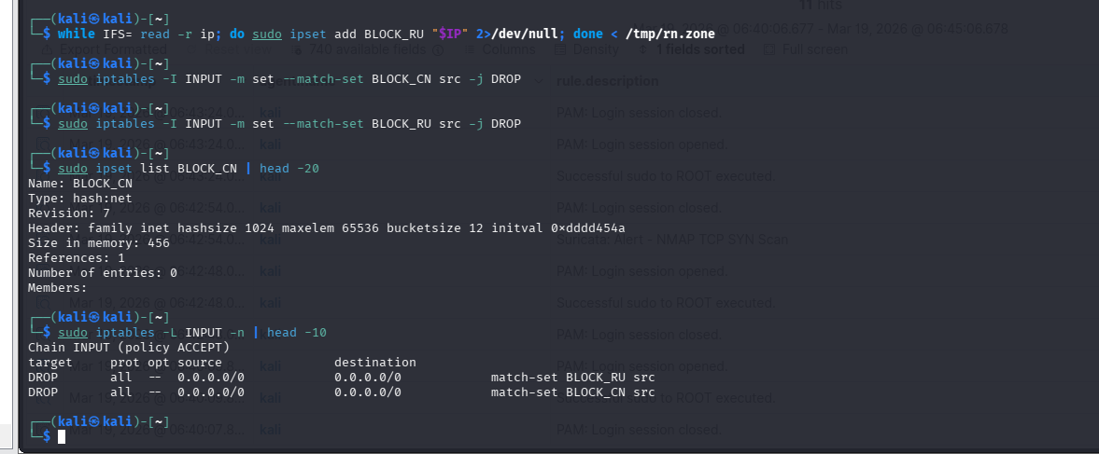› Creating and Populating ipsets
$ sudo ipset create BLOCK_CN hash:net
$ sudo ipset create BLOCK_RU hash:net
$ while IFS= read -r ip; do sudo ipset add BLOCK_CN "$ip" 2>/dev/null; done < /tmp/cn.zone
$ while IFS= read -r ip; do sudo ipset add BLOCK_RU "$ip" 2>/dev/null; done < /tmp/ru.zone
$ sudo ipset list BLOCK_CN | head -20
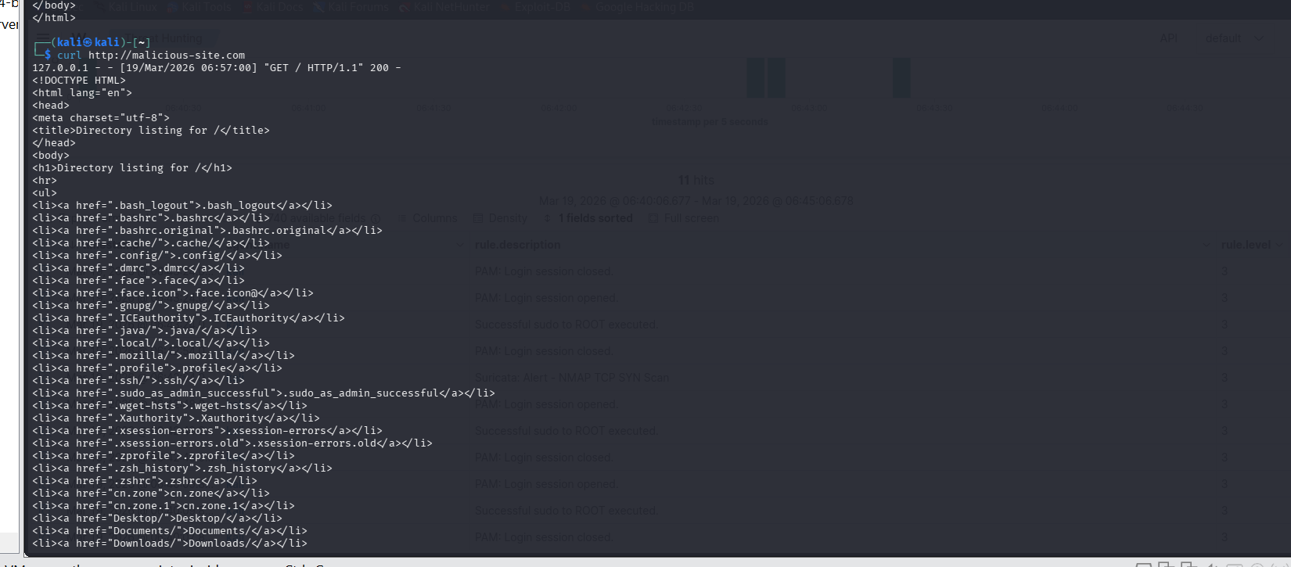› iptables DROP Rules
$ sudo iptables -I INPUT -m set --match-set BLOCK_CN src -j DROP
$ sudo iptables -I INPUT -m set --match-set BLOCK_RU src -j DROP
$ sudo iptables -L INPUT -n | head -10

DROP silently discards the packet — the sender receives no response and does not know whether the host exists. REJECT sends an ICMP port-unreachable or TCP RST back to the sender, which confirms the host exists but refused the connection. DROP is preferred for perimeter blocking because it provides no information to the attacker and consumes fewer resources.
NOTE: ipset entries are not persistent across reboots by default. They live in kernel memory. In a production deployment, ipset save and ipset restore at boot, or a firewall management layer like nftables with a saved ruleset, would be used. For this lab, the rules were verified within the session.
› Domain Blocking via /etc/hosts
Two domains were blocked by redirecting them to localhost in /etc/hosts. This is a local access control technique that prevents the machine from resolving those domains to their real IP addresses.
$ sudo nano /etc/hosts
Added entries: 127.0.0.1 malicious-site.com and 127.0.0.1 blocked-domain.com
$ curl http://malicious-site.com
$ curl http://blocked-domain.com
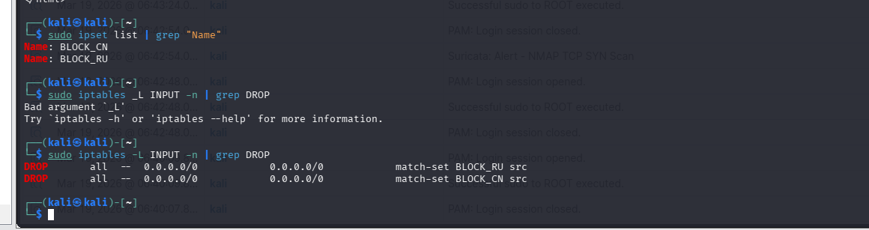
› Wazuh Alerts for Blocked Traffic
iptables DROP rules do not generate Wazuh alerts by default because dropped packets do not produce log entries in the files Wazuh monitors. To make blocked traffic visible in Wazuh, iptables LOG target rules would need to be added before each DROP rule, writing matches to the kernel log, which Wazuh can then read via the /var/log/kern.log localfile block. This was noted as a configuration enhancement for production environments.
// REFLECTIONS & LESSONS LEARNED
› Key Technical Takeaways
- 01. The af-packet interface setting in suricata.yaml is the single most critical configuration. A wrong interface name causes Suricata to start cleanly with no errors while seeing no traffic. Always verify by checking fast.log after generating test traffic.
- 02. The default-rule-path in suricata.yaml must be a directory path, not a file path. Appending a filename to the path causes Suricata to look for rule files in a non-existent subdirectory, silently loading zero rules.
- 03. alert http rules require Suricata's HTTP application layer parser to be active and processing the traffic correctly. Raw TCP rules (alert tcp) match byte content regardless of protocol parsing, but produce more false positives.
- 04. The threshold keyword is essential for volume-based attack detection. Without it, a 10-second ICMP flood would generate thousands of identical alerts making the log unusable. type limit fires once per time window; type threshold fires after a count is reached.
- 05. ipset is the correct tool for large-scale IP blocking. Individual iptables rules for 50,000+ CIDR ranges would degrade performance. A single ipset referenced in one rule provides O(1) lookup regardless of set size.
› Conceptual Takeaway
The correlation exercise on Days 18-19 was the most important task of the week. Seeing a Suricata network alert and a Wazuh FIM alert side by side — understanding they are two observations of the same activity from different vantage points — illustrates what defence in depth actually means in practice. Neither event alone is conclusive. Together they tell a story. That is the analytical shift from monitoring to investigation.

[ END OF REPORT ] // WEEK 3 // UNYIMEABASI SUNDAY JONES // INTERNAL USE ONLY

